CHAPTER 7: Chemical reactions
Worksheet 7.4

Acid rain
Science Quest 9: pages 268–9
Answers
1. In our modern society we produce acidic gases that enter our atmosphere and produce acid rain. Examine the drawing below. It shows a coal-fired factory and a car.
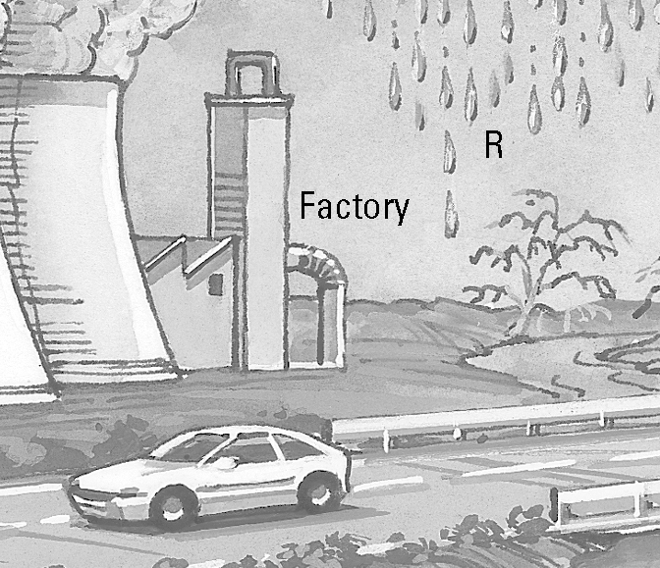
(a) Identify two acidic gases emitted from the chimney.
Sulfur dioxide, carbon dioxide

(b) Identify an acidic gas emitted by the car exhaust.
Nitrogen dioxide, carbon dioxide

(c) Acidic gases dissolve in rainwater. Rainwater is collected at R before it reaches the ground. What colour would litmus turn in this rainwater?
Red

2. The photograph below shows the effect of acid rain on marble statues.
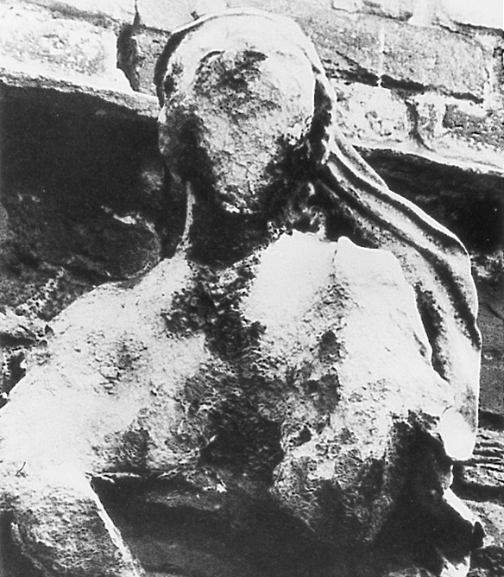
(a) The marble statue is made from a base called calcium carbonate. Propose why the statue is readily attacked by acid rain.
The acid rain neutralises the base and dissolves it.

(b) When acidic rain containing dilute sulfuric acid attacks the statue, calcium sulfate, water and carbon dioxide are formed. Write a word equation for this reaction.
© Austral International
Calcium carbonate + sulfuric acid → calcium sulfate + water + carbon dioxide

3. The following tabulated data compares various gases in a city on a clear day versus a smoggy day.
(a) Plot a column graph of this data on the grid provided. Use an appropriate key.
Gas | Clear day concentration  (ppm) | Smoggy day concentration  (ppm) | 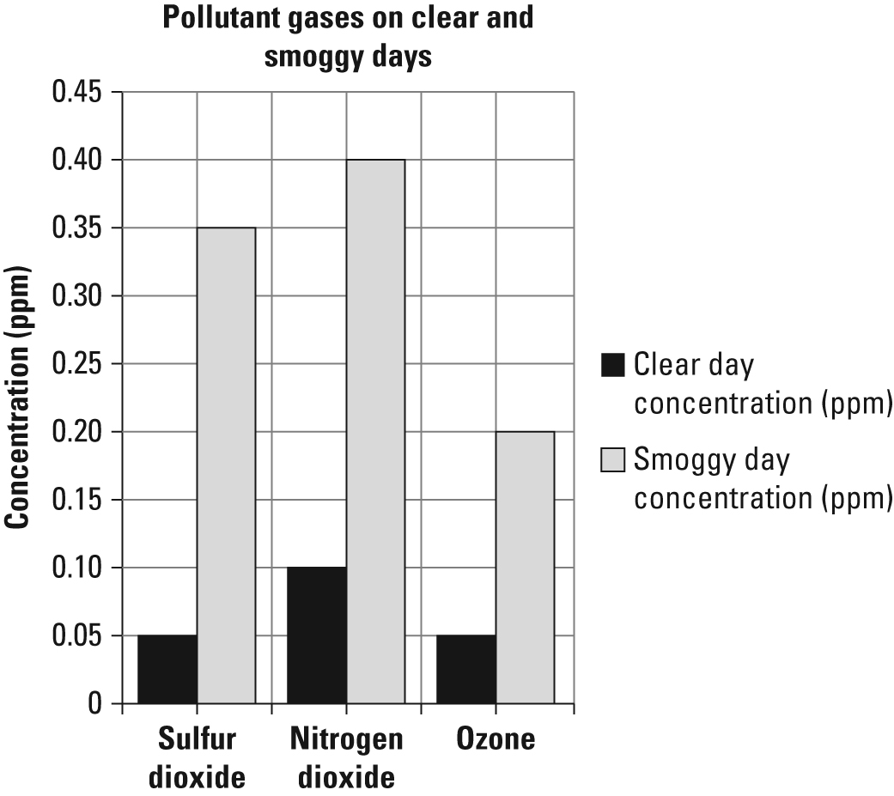
Sulfur dioxide | 0.05 | 0.35
Nitrogen dioxide | 0.10 | 0.40
Ozone | 0.05 | 0.20
(b) Identify the major cause of the rise in concentration of these gases on a smoggy day.
On a smoggy day the wind is not blowing sufficiently to clean out the air pollution from cities, so the concentration of these gases rises.

